7.41: a) 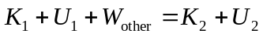
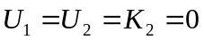
The work-energy expression gives 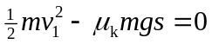
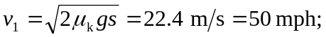 the driver was speeding.
- 15 mph over speed limit so $150 ticket.

